ANIMAL DETECTION SYSTEM BY USING PATTERN RECOGNITION

**Ananya D. Purohit**

Department of CSE

G.H Raisoni College of Engineering Nagpur, India

[ananya.purohit.cs@ghrce.raisoni.net](mailto:ananya.purohit.cs@ghrce.raisoni.net)

**Sargam A. Lokhande**

Department of CSE

G.H Raisoni College of Engineering Nagpur, India

[sargam.lokhande.cs@ghrce.raisoni.net](mailto:sargam.lokhande.cs@ghrce.raisoni.net)

**Shweta G. Rekalwar**

Department of CSE

G.H Raisoni College of Engineering Nagpur, India

[shweta.rekalwar.cs@ghrce.raisoni.net](mailto:shweta.rekalwar.cs@ghrce.raisoni.net)

**Umang U. Agrawal**

Department of CSE

G.H Raisoni College of Engineering Nagpur, India

[umang.agrawal.cs@ghrce.raisoni.net](mailto:umang.agrawal.cs@ghrce.raisoni.net)

**Aditya N. Turankar** Assistant Professor Department of CSE

G.H Raisoni College of Engineering Nagpur, India

[aditya.turankar@raisoni.net](mailto:aditya.turankar@raisoni.net)

***Abstract - Nowadays major cause of the road accidents are animals which being a current issue over the times. Accidents due to animals crossing the road at unanticipated moments have still been a significant cause of death of animal, especially on the roads near the dark, dense and thick timber areas. Current issues reducing collisions between automobiles and wildlife on the road, analogous incidents being in an imbalanced ecosystem, and significant public coffers. This paper proposes a pattern recognition model that efficiently detect the animals. This paper uses YOLO model which provides the motorist backing system which gives the driver an alert when the animals are being spotted in the cameras within the region. Whenever there is an animal lying on road this model will capture the animal for spanning of one or half of an hour then it’ll send the details or message to NMC regarding the cleanliness of dead animal. This model gives applicable results after the detection of animal and system gives an alert to make the motorist apprehensive about the approaching animal. This system is used to detect and classify animals in real-time, thereby enhancing road safety and mitigating accidents.***

***Keywords: Road safety, Pattern Recognition, Real-time Animal Detection, Alerts, Image Processing, You Only Look Once (YOLO).***

## INTRODUCTION

The rising trend in accidents involving random animals, as indicated by a nearly 23% increase in incidents over the last six years, magnifies the urgency of finding viable and sustainable solutions. The recent spike, averaging eight random animal injuries per day from April to June, paints a worrisome picture that necessitates swift and effective counter measures. This paper aims to delve comprehensively into the multifaceted issue of road accidents caused by animals, shedding light on the often-overlooked statistics and intricacies that underpin the urgent need for a nuanced and holistic solution. The repercussions of accidents involving animals extend beyond the immediate human- animal conflict, permeating into the realm of public safety and societal responsibility. It has become increasingly

evident that mitigating this issue requires a thorough understanding of the underlying factors contributing to these accidents, coupled with innovative technological interventions to provide real-time solutions for both prevention and response.

In the face of such challenges, it becomes imperative to dissect the underlying causes of these accidents. Factors such as poor lighting on roads and over-speeding have been identified as significant contributors, underscoring the need for a multifaceted approach that addresses both infrastructural and behavioural aspects. Green activist Jaydeep Das's firsthand account of an injured cow on Amravati Road serves as a poignant reminder of the urgency of implementing solutions that go beyond mere statistical analysis.

Given the escalation in road accidents involving animals and the subsequent toll on both human and animal life, there is an undeniable urgency to address this issue comprehensively. It is imperative to devise a high-efficiency model with quick recognition capabilities to detect animals on roads promptly. This model should not only serve as a preventative measure to reduce highway collisions but also facilitate the timely reporting of injured or deceased animals to the NMC for proper cleanup.

The complexity of the issue is further underscored by the fact that nearly one-third of the injured animals perish either immediately or within a few days of the accidents. This grim reality emphasizes the need for immediate intervention strategies that not only prevent accidents but also address the aftermath, ensuring humane treatment and swift cleanup operations.

The alarming statistics gleaned from the Nagpur Municipal Corporation (NMC) veterinary department's data underscore the severity of the situation. Over the past four months, a staggering 1,011 animals have fallen victim to

road accidents in the municipality alone, adding a poignant layer to the narrative. Furthermore, a majority of these animals succumbed to their injuries, highlighting the urgency of addressing the root causes of these accidents. The longitudinal data spanning from 2011-12 to July 2019 paints a bleak picture, revealing that a cumulative total of 11,915 random animals have suffered injuries in road accidents. This substantial figure brings to the forefront the necessity of a proactive and efficient approach to curbing these incidents.

research paper compared that animals come in various size, shape, disguise, colour and their behaviour is also not entirely predictable.

## TABLE 1 . LITERATURE SURVEY

1. LITERATURE REVIEW

|  |  |  |  |
| --- | --- | --- | --- |
| **Paper Title** | **Author** | **Year** | **Review** |
| Highway collision avoidance by  detection of animal  images | Mahima R., Meecus  M. Manjari K | 2023 | In aspects of  recognition, the  suggested method affairs a total precision of about  85.51 percent |
| Animal Detection Alert System | Mera S, Sharmika sree, R Priya darshini, K P.V  Varshita, R.  SaiChanith  a | 2022 | If an animal is seen, the amount of time it takes to avoid a collision with a vehicle is insufficient |
| Animal intrusion detection in highway area | J. Joshua Daniel  Raj,C.N  Sangeetha, Sarthak Ghorai | 2022 | The anker box with highest intersection over union with the ground thruth bounding box is used for makin final  prediction. |
| Developm ent of  animal detection system | Sheik Mohamme  d. S,T.  Sheela,T. Muthuman ickam | 2022 | This system uses to propose AI  technology to differentiate animal category. |
| Detection of Wildlife Animals using Deep  Learning | Sreedevi K L, Anitha Edison | 2021 | The method is developed using seperable convolution layer. |
| Animal Detection  for Road safety using Deep  Learning | Sanjay Sartha, Sudhair Sidhaantha n B | 2021 | They segmenting the animals with the help of a vast open-source dataset |
| Detection of big  animals on images  with road scenes using deep  learning | Dmitry Yudin, Anton Sotnikov, Andrei Krishtopik | 2019 | The software implementation was done using the Keras and PyTorch deep learning libraries and NVidia CUDA technology |

The goal of the paper is to enhance the road safety and mitigating accidents thereby reduces the impact on wildlife populations & their homes by automating the identification and localization of animals in images or videos as accurate and real-time detection. In addition, this modal helps to convey the message or communication directly to the NMC regarding the cleanliness of road due to dead animals. It contributes to discussion, reduces manual efforts, and enhances our understanding of animal behaviours. As a versatile tool, it holds great pledge in shaping a more informed and sustainable concurrence between humans and the animal area.

We‟ve taken references from numerous former research papers related to this model. We set up that, some models

demanded configuration, speed, and cost. Hence, we‟re proposing a model that beats the other model.

Dmitry Yudin, Anton Sotnikov, Andrey Krishtopik (2019)[7] Detection of Big Animals on Images with Road Scenes using Deep Learning used colourful high-level deep literacy algorithms to detect the object and used data set grounded on Google Open Images and COCO datasets containing around 20,000 arbitrary images. This paper used network infrastructures similar as VOLOv3, Fast R-CNN. The drawback of this model is high element power. They need high computational energy and speed for result.

Pravin A. Dhulekar , Dr. Sanjay T. Gandhe (2018)[8]

Significant animal detection and nonstop business monitoring on roadways used radar processing technology to shoot out an infrared ray from the tower or vehicle. The system warns the driver and truck when the shaft gets intruded and disturbed. This model gives out lots of false alarms.

As discussed in Significant animal detection and nonstop business monitoring on highways paper, radar processing technology sends out a UV. The ray from the tower or vehicle is outmoded and results in false-positive conditions.

Sanjay Sartha, Sudhir Sidhaarthan B(2021)[6] Animal Detection for Road Safety using deep learning uses high element power. They need high computational energy and speed for quick and efficient results.

Mahima R. Meenu M, Manjari K (2023)[1] Highway Collision Avoidance by Detection of Animal‟s Images

|  |  |  |  |
| --- | --- | --- | --- |
| Vision Based  Technique for Animal Detection | Pravin A. Dhulekar, Dr. Sanjay  T. Gandhe | 2018 | As started before the most of the previous work is based on sensors which provide less accuracy with large detection  time |

## METHODOLOGY

**System Architecture**

The system comprises a primary camera mounted at the front of the vehicle to provide a wide viewpoint covering the entire road. This camera is connected to an embedded system capable of real-time image processing to detect the presence of animals on the road. At the core of the system is a vision-based algorithm utilizing feature extraction and data classification techniques. The system architecture includes a multi-core CPU for general operations and data preprocessing, along with a dedicated GPU to accelerate deep learning model inference. A minimum of 16 GB RAM is used for efficient handling of large datasets and model operations. Network connectivity and a stable power supply are essential for fast internet connection, data download, model updates, and potential cloud integration. A high- quality camera or webcam captures images or video streams.

The Raspberry Pi is utilized, and a hardware support package for OpenCV facilitates easy deployment of OpenCV files onto the Raspberry Pi. The Raspberry Pi interface is linked with a red blinking light in the proposed system. A webcam serves as the acquisition device, capturing images for animal recognition and providing sample images for further processing. The methodology is structured into various stages, beginning with the processing of input video frames, followed by image preprocessing, application of the YOLOv8 algorithm, and subsequent steps involving feature extraction, bounding box prediction, and post-processing. Each stage is designed for the accuracy and efficiency of the animal detection system.

Screen Display

Power Supply

Raspberry pi Board

Camera Module

Figure 1: Block Diagram of System Overview

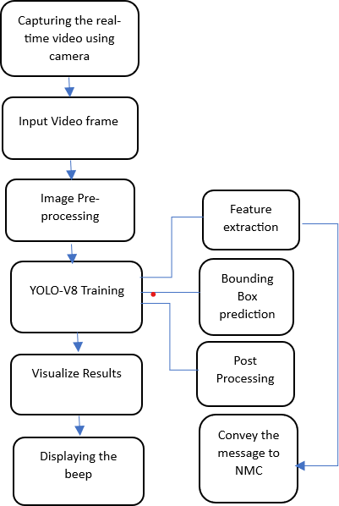figure 2: Work Flow

1. *Database Creation*

Videos are collected from camera module in which the captured images will be processed and segmented.

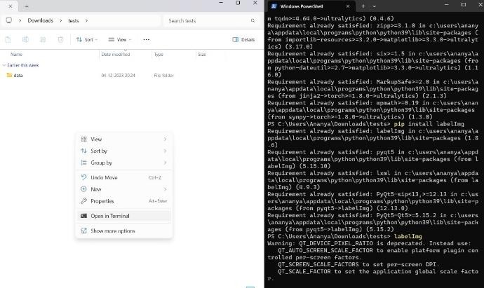

figure 3: Own Training & Testing Datasets

Training Dataset: Training data/set is the initial data used to train deep learning models. The extracted images are grouped as the training set. These training datasets are fed to ultralytics to teach them how to make prediction/perform a desired task which refers as supervised learning.

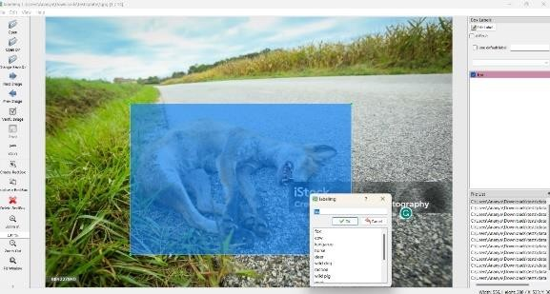

figure 4: Training dataset

Testing Dataset: Test dataset i.e., the images which are needed to be tested is given to the trained model through which the detection is done.

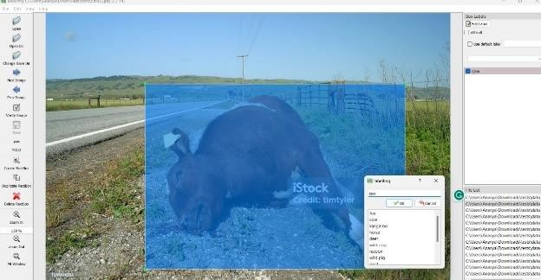

figure 5: Testing dataset

1. *Processing the input video frame*

The camera module will lead to capture the video of an animal, also this captured video will be processed and segmented using the coco.txt model. This step will further perform certain actions including resizing, normalization & format conversion, comparing the captured image with our trained a dataset.

1. *Image Preprocessing*

In order to reduce noise from photos, median filtering is utilized. As a result of its ability to reduce noise while preserving the edges, it is widely employed. Noises like salt and pepper may be eliminated using this product. The preprocessing channel for YOLOv8 includes resizing and padding the image to a square shape, followed by homogenizing the pixel values and converting the image to a tensor. substantially used for segmenting the intriguing patterns from background of a given image and plus apply some noise filtration, smoothing and normalization to correct the image from different errors.

1. *YOLOv8 Algorithm*

YOLO is an condensation of the term „You Only Look Once‟. YOLOv8 is designed to be fast, accurate, and easy to use, making it an excellent choice for tracking the movements of any object accurately and gives instance segmentation, and image classification.

The pre-processed image is then undergoing YOLO algorithm classification in which image is employed with classification which detect the animal.

1. *Feature Extraction:* The process of feature extraction adheres to stringent requirements to ensure its efficacy. Firstly, intraclass variance must be minimized, signifying that features derived from different samples of the same class should exhibit proximity. This ensures that the extracted features accurately represent the common characteristics shared within a particular class, optimizing the subsequent stages of our methodology for animal detection.

Conversely, interclass separation should be maximized, demanding that features derived from samples of different classes exhibit significant differences. This criterion ensures that the extracted features effectively capture the distinctions between various classes, facilitating precise classification. The success of our classification tasks hinges on the ability of the extracted features to discriminate between classes with high accuracy.

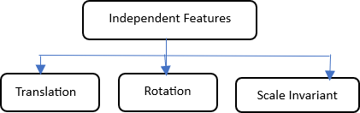

Figure 6: Feature extracting from video frame

1. *Bounding Box Prediction*: The bounding box is an outline that highlights the object in an image & defines co-ordinates of centre of bounding box. Each bounding box consists of following attributes:
   1. Components (X, Y)
   2. Frame Width
   3. Frame Height
   4. Class (example person, car, bag, etc)
   5. Confidence (config)

These are smoothed into a single dimension in the affair tensor. The pre-processed image is then it undergoes YOLO algorithm classification in which image is employed with classification which detect the animal. Then the prediction image will be considered which contains bounding boxes.

1. *Post Processing:* The neural network that is created & trained for classification and determine a class of object on image and returns it is name & possibility of this prediction. It does contain three main components Train, Predict, Format. The post processing algorithm is known to be as Non-Maximum Suppression (NMS). It is a batch unit, thus we need to figure out the number of batches and prepare bbox, conf, and class_id affairs/output for each batch (one image).

## VISUALIZE RESULTS

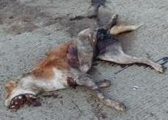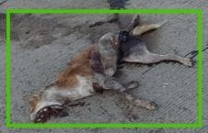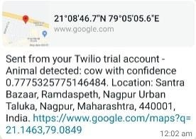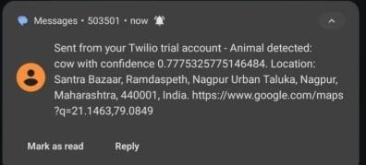

Transmitter

animal captured

animal detected

The animal detection is done by filtering noises and gives the labelled data of image. After training the model, the testing has done. The result is as follows

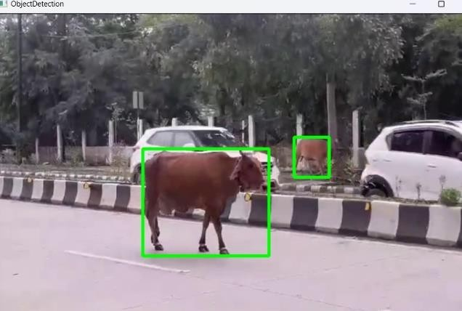figure 7: Cow Detected

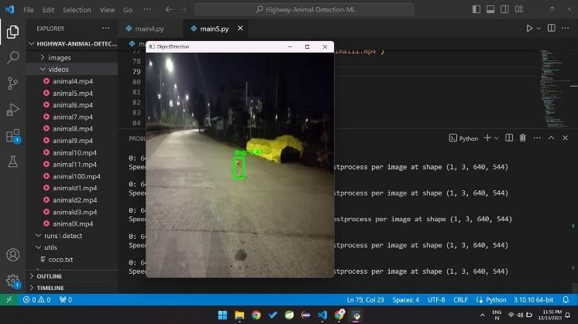

figure 8: Dog Detected



figure 9: Dead Animal Detected

We tested the model with another real-time image of a cow & dog. When the camera is placed above the dashboard facing the road, the model gives 93% accuracy. All it needs is a reasonable quality video frame and camera. The model can also be used in wild areas and farms to monitor the movements of animals.

message with exact

location of dead animal notification message on mobile

Figure 10: Conveying the massage of dead animal to NMC

We tested the model and get the result of actual result of dead animal. At the very first step, the dead animal on road is captured and detected by YOLOv8 model enhancing the features of dead body of animal. In this research paper, we implemented the key aspect as if there were any dead body of an animal then it will directly convey the message to the NMC regarding the cleanliness of same dead animal. For conveying the message directly to the NMC we have imported the GSM Module [Global System for Mobile Communication]. This GSM module will send the message that will be received by the NMC including the location and details about the dead animal.

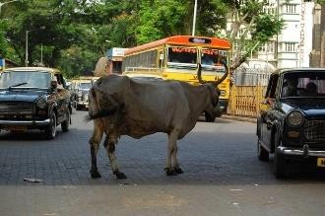

figure 11: Real-time image of animal detection on road

## FUTURE SCOPE

A novel pattern recognition model has been proposed to efficiently detect animals on roads, aiming to significantly reduce collisions on highways. The primary objective includes a feature to promptly notify the National Maintenance Center (NMC) about deceased animals on roads, ensuring timely cleanup for the maintenance of road cleanliness. While the system detects the real-time animals on highways and notify the drivers to their presence, it does so with significant restrictions. Our system tracks the animal movements accurately on road to anticipate the collision risks. Animals within 100m distance will detect the animals using the proposed architecture, even if an animal is seen, the amount of time it takes to avoid a collision with a car is

insufficient. This system can be efficient in detecting the creatures during night by using night vision camera module. To address challenges, especially during night time, the system is designed to incorporate a night vision camera module, enhancing visibility and detection capabilities in low-light conditions.

## CONCLUSION

The field of wildlife management and research has undergone significant advancements through the implementation of automated identification and localization of animals in images and videos. This innovative approach has not only increased efficiency and accuracy but has also provided valuable insights, streamlined wildlife research and playing a crucial role in conservation efforts. The transformative nature of these automated processes reduces reliance on manual labor, making tasks that once demanded substantial human effort more precise and expeditious.

By providing real-time insights into animal behaviors and movements, this technology enables informed decision- making for sustainable conservation practices.An integral part of this technological advancement is the YOLO-V8 algorithm, which plays a crucial role in wildlife animal recognition using camera modules. Leveraging the capabilities of camera modules, the algorithm facilitates the seamless integration of visual data, enabling accurate identification and localization of wildlife. The focus on the proposed architecture's accuracy in detecting animals on highways is particularly noteworthy.

## REFERENCES

1. M. Manhaleswaran, M. Azhagiri, “A comparison of different learning algorithm for wildlife detection and classification in animal conservation applications” 2023 Third International Conference on ICAIS (2023)
2. Mahima R, Meenu M, Manjari K, Rovenal S, Keerthana Sri S, Sruthi M.P Proceedings of the International Conference on Intelligent Data Communication Technologies and Internet of Things (IDCIoT 2023) IEEE Xplore Part Number: CFP23CV1-ART; ISBN: 978-1-6654-7451-1
3. Sanjay Santhanam, Sudhir Sidhaarthan B, Sai Sudha Panigrahi, Suryakant kumar Kashyap, Bhargav Krishna Duriseti 2021 International Conference on Computational Intelligence and Computing Applications (ICCICA) | 978-1-6654-2040-2/21/$31.00

## ©2021 EEE | DOI: 10.1109/ICCICA52458.2021.9697287

1. Vigneshwaran Palanisamy, Nagulan Ratnarajah 2021 21st International Conference on Advances in ICT for Emerging Regions (ICter) | 978-1-6654-6686-

## 8/21/$31.00 ©2021 IEEE | DOI:

10.1109/ICter53630.2021.9774826

# Dmitry Yudin, Anton Sotnikov, Andrey Krishtopik, Detection of Big Animals on Images with Road Scenes using Deep Learning, 2020

1. N.K EL Abbadi and E. M. T. A. Alsaadi, “An Automated Vertebrate Animals Classification Using Deep Convolution Neural Networks,” 2020 International Conferences on CSASE, 2020,pp. 72-77, doi: 1109/CSASE48920.20202.9142070
2. Zhang, X.-Y., Liu, C.-L., & Suen, C. Y. (2020). *Towards Robust Pattern Recognition: A Review.* Proceedings of the IEEE, 108(6), 894-922.

doi:10.1109/jproc.2020.2989782

1. Nidhal K. El Abbadi; Elham Mohammed Thabit A. Alsaadi, An Automated Vertebrate Animals Classification Using Deep Convolution Neural Networks, 2020
2. Dmitry Yudin; Anton Sotnikov; Andrey Krishtopik, Detection of Big Animals on Images with Road Scenes using Deep Learning, 2020
3. C. Ahuja, L-P. Morency, T. Baltrusaitis, and “Multimodal machine literacy: A check and taxonomy,” IEEE Trans. Pattern Anal. Mach. Intell., vol. 41, no. 2,

pp. 423-443, Feb. 2019.

1. K. He, H. Fan, Y. Wu, S. Xie, and R. Girshick, “Momentum contrast for unsupervised visual representation learning,” 2019, arXiv:1911.05722. [Online].
2. Rnovszky, Tibor & Kamencay, Patrik & Orjesek, Trichard & Benco, Miroslav & Sykora, Peter. (2019). Animal Recognition System Grounded on Convolutional Neural Network. Advances in Electrical and Electronic Engineering.
3. Yudin, A. Sotnikov, and A. Krishtopik, “Detection of Big Animals on Images with Road Scenes using Deep Learning,” 2019 International Conference on (IC- AIAI), 2019, pp. 100-1003, doi: 10.1109/IC AIAI48757.2019.00028
4. Benjamin Kellenberger; Diego Marcos; Sylvain Lobry; Devis Tuia, Half a Percent of Labels is Enough: Efficient Animal Detection in UAV Imagery Using Deep CNNs and Active Learning, 2019
5. Mane, Shraddha & Mangale, Supriya. (2018). Moving Object Detection and Tracking using Convolutional Neural Networks. 1809-1813. 10.1109/ICCONS.2018.8662921
6. H. Yousif, J. Yuan, R. Kays and Z. He, “Human- animal detection from clustered camera-trap images using joint background modelling and DL classification,” 2017 IEEE (ISCAS), 2017, pp. 1-4, doi:10.1109/ISCAS.2017.8050762
7. Zhu, Chunbiao et al. “Towards Automatic Wild Animal Detection in Low Quality Camera-Trap Casts Using Two-conducted Perceiving Residua; Pyramid Networks.” 2017 IEEE ICCVW (2017): 2860-2864
8. Mingxing Tan and Quoc V. Efficient Net: Rethinking Model Scaling for Convolutional Neural Networks, 2017, arXiv
9. WU, J. L. and W. Y. MA. A Deep Learning Framework for Coreference Resolution Based on Convolutional Neural Network. In: 2017 IEEE 11th International Conference on Semantic Computing (ICSC). San Diego: IEEE, 2017, pp. 61–64.

# He, K., Zhang, X., Ren, S., Sun, J.: Deep residual learning for image recognition. In: CVPR.

pp. 770-778 (2016).

1. Kamencay, P., T. Trnovszky, M. Benco, R. Hudec,

P. Sykora and A. Satnik. Accurate wild animal recognition using PCA, LDA and LBPH, In: 2016 ELEKTRO. Strbske Pleso: IEEE, 2016, pp. 62–67.